Chapter 9 : The Era of Thomas Jefferson
SECTION 1 : JEFFERSON TAKES OFFICE

- A BITTER CAMPAIGN OF ELECTION OF 1800
          - 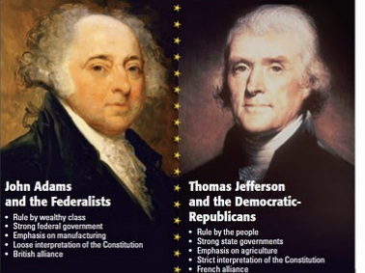
CANDIDATES OF ELECTION OF 1800: Jefferson, Burr, Adams, Pinckney
          - 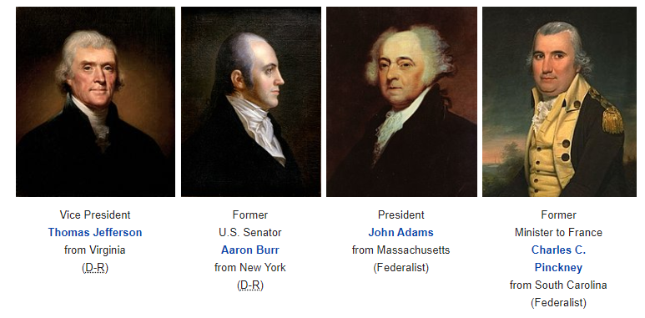
        - 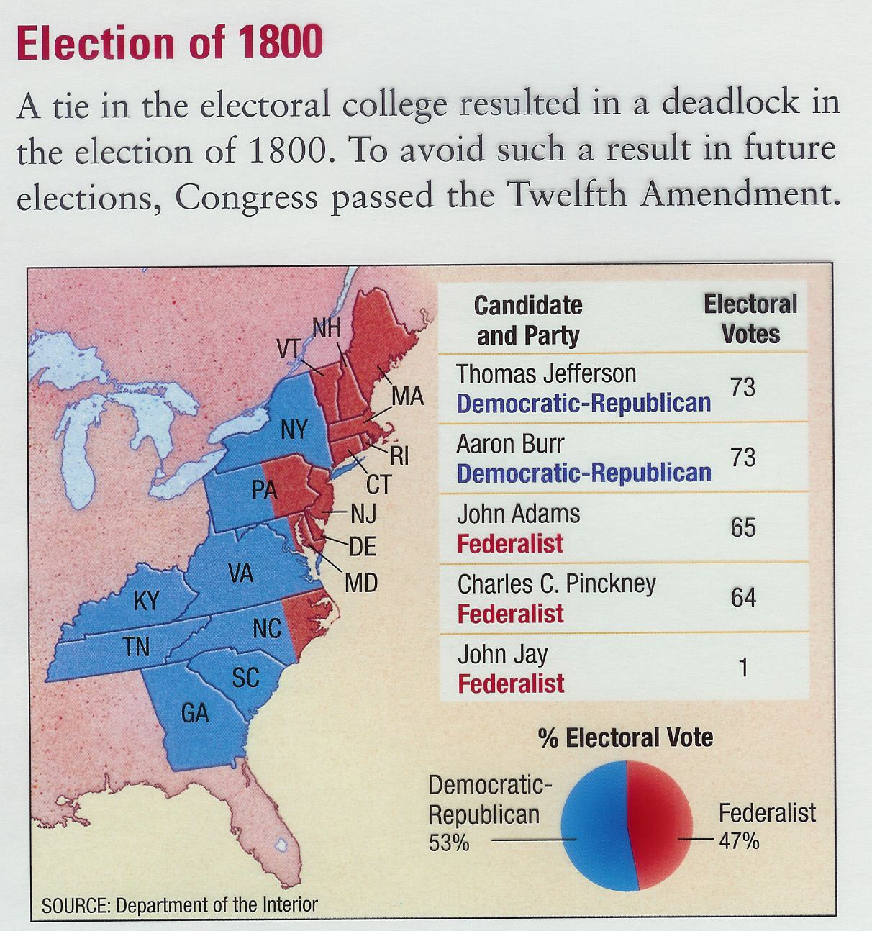
        - Thomas Jefferson ran against not only JOHN ADAMS but also someone from his own party, AARON BURR. They both received 73 votes. Now it is up to the Congress to decide who wins.
        - Thomas Jefferson defeats AARON BURR, with a vote by CONGRESS.
          - Because of this tie, CONGRESS passed the 12th AMENDMENT, where a President and Vice President would be elected separately.
        - John Adams was the first one in the White House, Thomas Jefferson was the first one to be Inaugurated in Washington D.C.
        - Jefferson would never let people bow to him, he shook their hands. He tried bringing the country together.
        - The first thing he does as President is he gets rid of SEDITION AND ALIEN ACTS.
      - JEFFERSON CHARTS A NEW COURSE FOR US GOVERNMENT
        - Jefferson believed that CONGRESS was to involved in economic affairs. He implements: “LAIZZES FAIRE”
          - LAISSEZ FAIRE, French term meaning LEAVE ALONE or HANDS OFF.
        - Jefferson did not think we needed a big army, he decides to cut the ARMY AND NAVY in HALF!
        - Jefferson believed taxes were too high, so he cuts them!
        - He releases people who were put in prison under the SEDITION ACTS.
      - THE SUPREME COURT & JUDICIAL REVIEW
        - JUDICIAL REVIEW – Allows the SUPREME COURT to strike down laws that are UNCONSTITUTONAL OR ILLEGAL. This was created in the JUDICIARY ACT OF 1789 in a case called MARBURY VS. MADISON
        - Thomas Jefferson decided to push for JUDICIAL REVIEW, but to do that he had to get rid of the judges on the SUPEME COURT that did not push for getting rid of UNCONSITITUAL LAWS. One of those judges was WILLIAM MARBURY.
        - Marbury vs. Madison
          - Under this Marbury vs. Madison, Judge Marbury sued Madison that he should not be fired as a judge. Marbury said that CONGRESS can review bad laws. The HEAD OF SUPREME COURT JOHN MARSHALL said, “NO ONLY THE SUPREME COURT CAN DO THAT”
          - This court gave SUPREME COURT the ONLY authority to overrule bad laws. Not Congress.

SECTION 2: THE LOUISIANA PURCHASE
            - THE NATION LOOKS WEST
              - By, 1800 more than 1 million settlers lived between the Appalachian Mountains and the Mississippi River. The USA was expanding west.
              - Most of these setter’s west were farmers. They relied on the Mississippi River to ship their crops. Spain made a treaty with America to allow America to ship along New Orleans and use the Mississippi River called the, “PINCKNEY TREATY”
              - NAPOLEON MAKES A MISTAKE INVADING RUSSIA
    - Napoleon had one more goal, conquer an area that was becoming a great power in the world… Russia.
    - He invaded Russia, but invaded in winter, his men were cold… their supply lines grew thin.
    - Russia burned the first city and retreated deeper into Russia. They did this many times making Napoleons troops keep marching.
    - Napoleon was forced to go back to Russia, this cost his country of France and men lots of MONEY. Now Britain and Russia both are invading France, Napoleon needs resources and money quick.
- BUYING LOUISIANA FROM FRANCE – 1803
  - President Thomas Jefferson (4th President of USA) wanted the area known as “New Orleans.”
  - Jefferson sent Robert Livingston, to discuss buying New Orleans for $10 Million dollars.
  - Upon arrival, the United States learns of a Rebellion in the Caribbean in a country called, “Haiti
    - Napoleon sends troops to Haiti to stop a rebellion in the Caribbean.
    - His men get an epidemic or disease that make his troops not move into North America

  - Livingston found out that Napoleon needed money and was offering up all of Louisiana to the United States of America.
  - Minister of Finance Francois de Barbe-Marbois, and Lord Talleyrand was the one who suggested this to Napoleon.
  - Livingston wrote back to Jefferson about the proposal. Jefferson sent James Monroe to offer Napoleon $15 million dollars for all the territory.
  - United States received: 827,000 square miles of land.
  - Officially done in December 20, 1803
  - Spanish did not want France to sell Louisiana to the United States because they felt threatened
  - 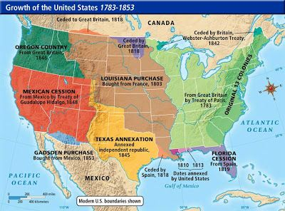
  - BELOW IS THE TRANSFER FROM FRENCH LOUISNANA TO AMERICAN LOUISIANA NEAR NEW ORELANS 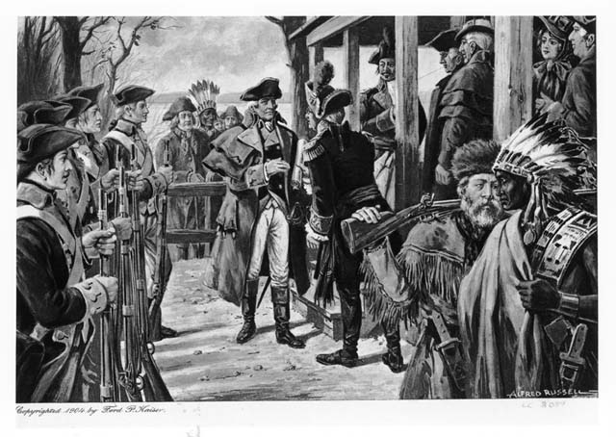
  - The one thing that the Louisiana Purchase did it doubled the size of the United States.
- LEWIS AND CLARK
  - Exploring Louisiana Territory (LEWIS AND CLARK) - NORTH
    - Thomas Jefferson wanted to explore Louisiana and make it to the Pacific Ocean.
    - He hired two individuals: Meriwether Lewis & William Clark
    - Hired them to follow and find the mouth of the MISSOURI RIVER
    - Started at the city of St. Louis
  - Jefferson told them to focus on the following things:
          - Map the territory - Drawl
          - Native Tribes - Drawl
          - Plants (Flora) – Drawl
          - Animals (Fauna) - Drawl
          - Soil - Samples
          - Rocks - Samples
          - Weather – Explain
          - What did they both have in common? Generals / Artists/ Botanists / Scientists
  - Lewis and Clark Expedition was called the “Corps of Discovery”
  - SACAJAWEA ENCOUNTER
    - They encountered a Shoshone Native American woman by the name of Sacajawea. Who spoke English and Shoshone.
    - She re-supplied them and guided them in the right direction through the Rocky Mountains onto Oregon.
    - She was married to a French fur trader by the name of Toussaint Charbonneau.
    - Toussaint Charbonneau said Sacajawea could not go on the expedition unless he went as well! Lewis and Clark agreed.
    - At the time Sacajawea met Lewis and Clark, she was pregnant with Charbonneau’s child.
                - She named him Jean Baptiste Charbonneau
                - Clark called the boy “LIL POMP” and eventually adopts him as his own and is educated in St. Louis
                - Jean Baptiste Charbonneau is the only child ever to make a United States coin.
                - 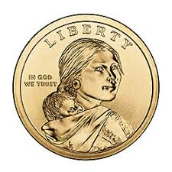
                - Sacajawea could not go far with Lewis and Clark on expedition because she had Jean Baptiste. During the expedition she ran into her Shoshone tribe and noticed her brother was the new chief. She had not seen him for over 12 years. Her brother sold horses to the Lewis and Clark expedition at the Shoshone village.
                - After having Jean Baptiste returns to Fort Mandan where Sacajawea gets sick and dies of diseases. Her husband did not care and had many Native American wives.
                - Sacajawea showed the 2 men the CONTINTNAL DIVIDE – where the rivers separate and run in opposite directions.

  - THE END OF THE VOYAGE
    - Toward the end of the voyage they reached the COLUMBIA RIVER where they built canoes and had to go through roaring rapids (55 miles worth)
    - They returned to Jefferson with much information in 1806.
    - Jefferson appointed Meriwether Lewis as the governor of Louisiana Territory
    - Jefferson later made William Clark an Indian Agent and a General of the Louisiana Territory Militia.
    - Both were rewarded with lots of money and gold!
  - 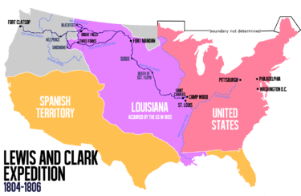
  - 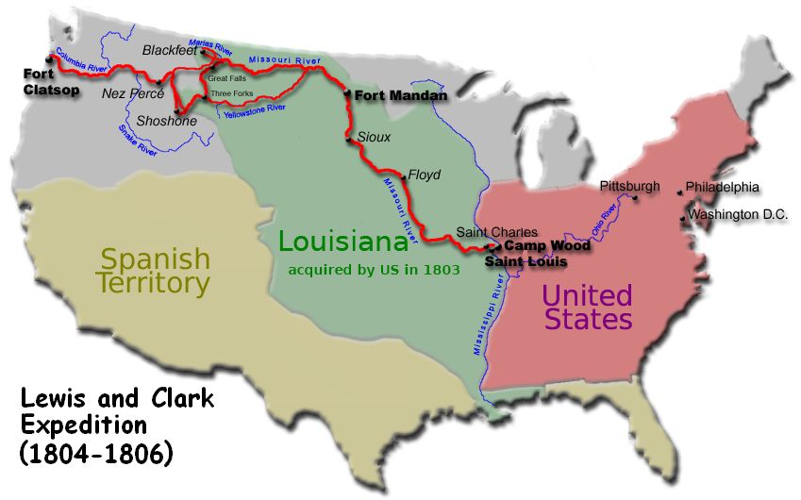
  - SACAJEWEA AT FORT MANDAN BELOW 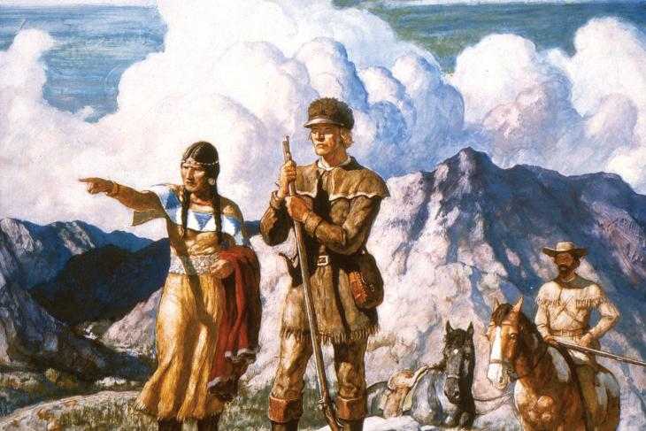
  - 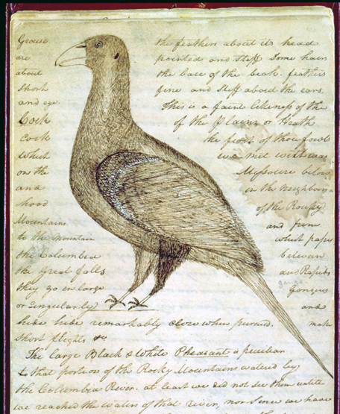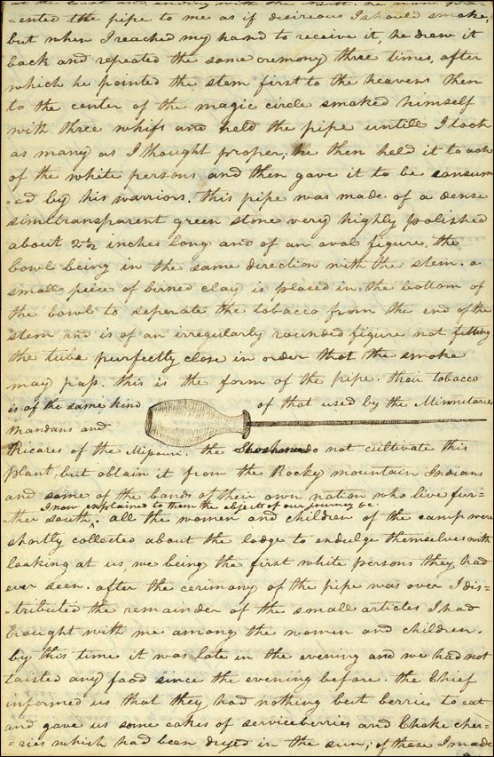
  - 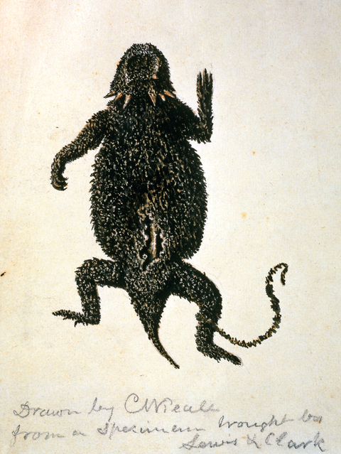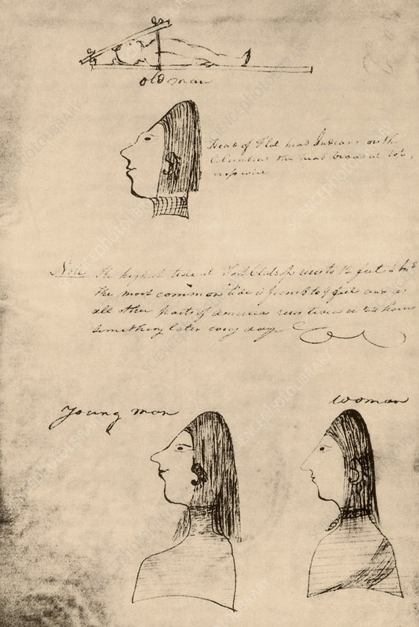

  - 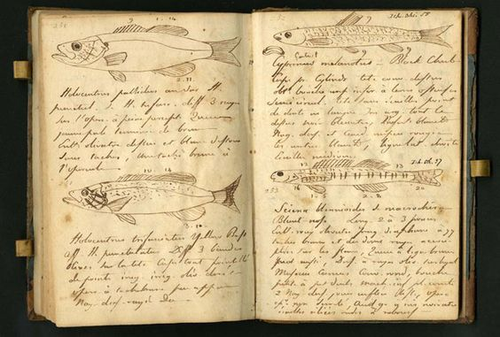

  - 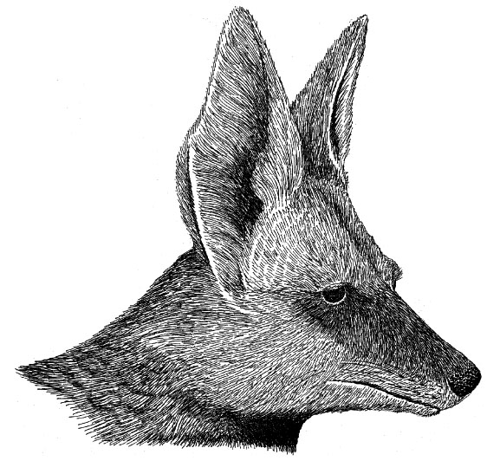

  - PIKES EXPEDITION – SOUTH LOUISIANA

  - 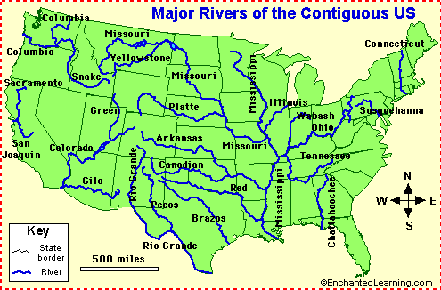

    - Zebulon Pike was a young General around age 20. He was instructed by Thomas Jefferson to search the mouth of the ARKANSAS RIVER.
    - He had all the same qualities as Lewis and Clark. He had even explored some of the regions of the Mississippi River.
    - Thomas Jefferson told him to head West from St. Louis to explore the Arkansas River, but to not get caught entering Spanish land. If caught he would be arrested, and all his documents and diaries taken.
    - Zebulon Pike made it to present day Kansas where the Arkansas River is, but his 2nd in command became sick: Lt. James Wilkinson.
                - Wilkinson was so sick he could not go on with Pike into present day Colorado. Pike ordered him to get well and stay and head South along the Arkansas River, while he followed it west.
                - Wilkinson became well and headed into present day Oklahoma.
    - Wilkinson took five men and the Osage Native American guide south down the Arkansas River to explore it.
  - Pike continued following the Arkansas River going west into Colorado.
  - He reached the Rocky Mountains, where he encountered heavy snowfall, He said, “I have encountered a high peak where there is waist deep of snow” He called this Pike’s Peak
  - Pike kept going west and went too far and wandered into Spanish territory and was arrested and sent home with no documentation.
  - Pike even though was arrested, made America very interested in the area that he explored.
  - 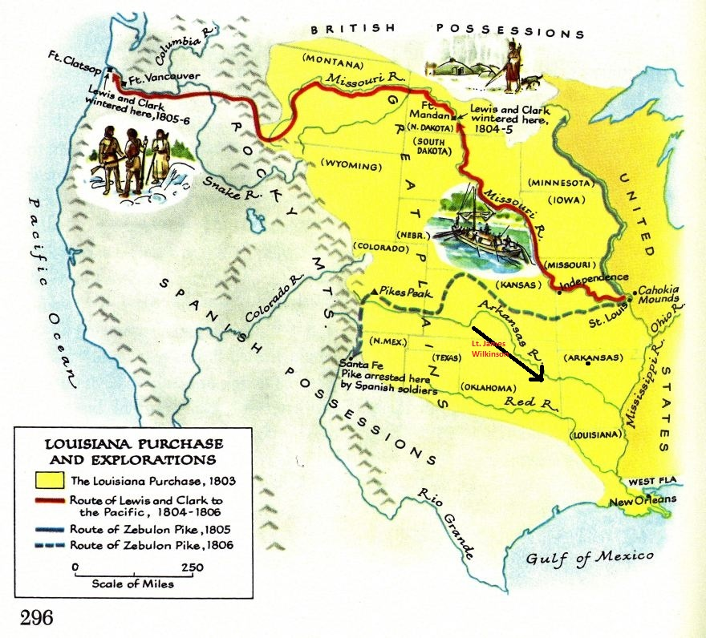

SECTION 3 : A TIME OF CONFLICT
      - DEFEATING THE BARBARY STATES
        - Under George Washington and John Adams, they managed to keep the country neutral, but the problem did not go away under Thomas Jefferson.
        - Thomas Jefferson orders the United States Army and Navy to be cut into half. He did not fear a war because he said there would be no war…. This was one of his only bad moves as President.
        - The United States continued sending over ships to trade with Britain and France and other countries of Europe.
          - Pirates begin to attack these ships in the Mediterranean Sea.
          - 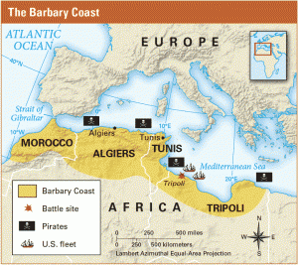
        - The Barbary States consists of : Morocco, Algiers, Tunisia, and Tripoli.
        - These pirates would raid ships steal goods and take sailors prisoner and sometimes convert them to pirates.
        - European countries began stopping these raids by Pirates by giving them tribute: paying them a fee in return for protection.
        - The raids became so bad that Thomas Jefferson ordered the Marines to raid Tripoli, “TO THE SHORES OF TRIPOLI.” The Marines would yell!
        - After Thomas Jefferson invaded Tripoli, not many Pirates attacked American ships much more.
      - AMERICAN NEUTRAILITY IS CHALLENGED
        - Britain and France was still around and in 1803 both countries were fighting each other again!
        - IMPRESSMENT and ATTACKING AMERICAN ships began again. Between 1803-1807 France attacked 500 American ships. Britain seized over 1,000. France did not do IMPRESSMENT, Britain did AGAIN!
        - Because of the attacks, Thomas Jefferson creates an “EMBARGO ACT” on Napoleon of France and King George III of Britain.
          - EMBARGO – Where a country stops all trade with another.
          - 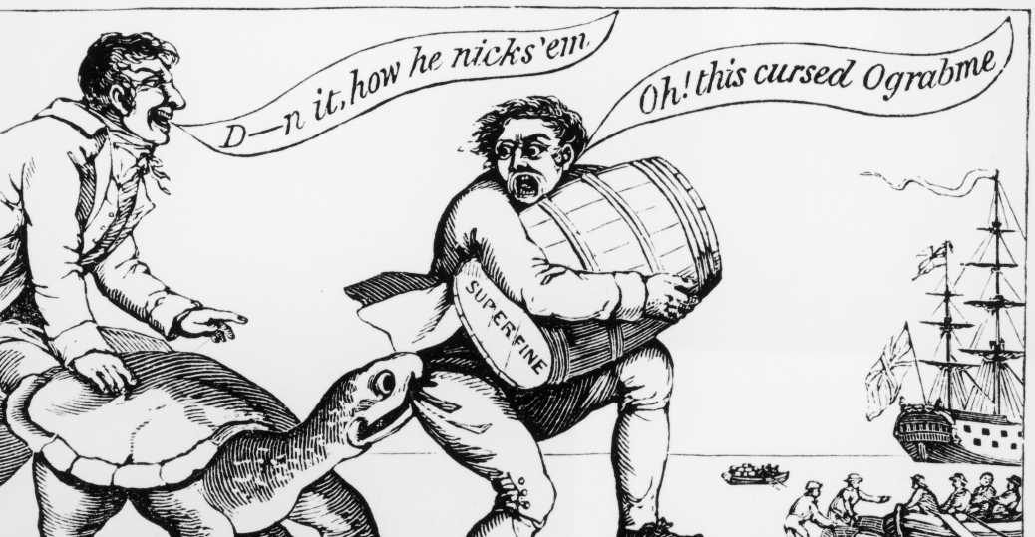
        - Because of Thomas Jefferson’s EMBARGO ACT, it hurt AMERICA vs. helped. Trade went from 109 million to 25 million in just 1 year.
        - Crops began to decline, farmers could not afford goods. Many Americans lost their jobs after the Embargo Act.
        - Thousands of Americans turned to Smuggling during the Embargo Act. Just like the American Revolution.
        - In 1809 just before Thomas Jefferson leaves office, the Embargo Act is lifted.
      - TECHUMSEH AND THE PROPHET TENSKWATAWA
        - Many settlers move West, in 1803 Ohio becomes a state, many States are popping up in the NW Territory like Indiana.
        - Native Americans declined from diseases, and many Americans ran into their lands.
        - Native Americans begin to fight back, two Shawnee men: Tenskwatawa “THE PROPHET” and Tecumseh, urge Natives to join and fight back. TENSKAWATA urged Natives to preserve their old ways.
        - Tecumseh gathered Natives to take up arms, He got Western Tribes into a league to take out the white man. This was in INDIANA TERRITORY (NW TERRITORY REGION)
        - 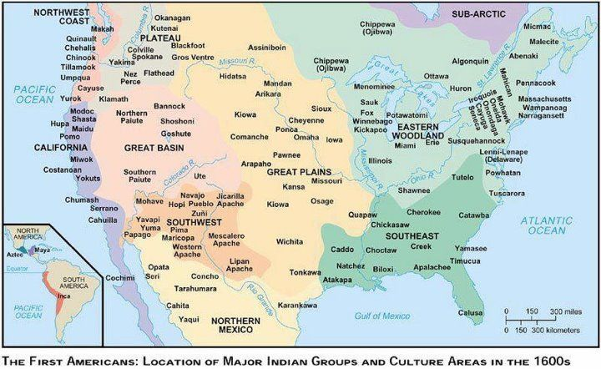
        - 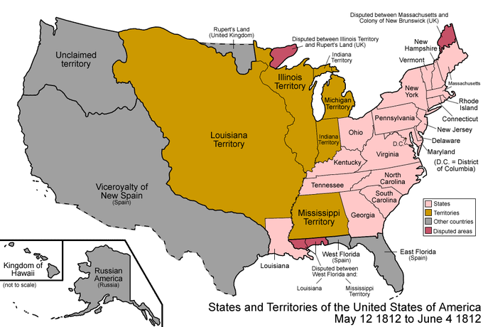
        - Eventually Tecumseh was defeated by WILLIAM HENRY HARRISON at INDIANA TERRITORY, but escaped where he continued to raid for many years. But they struggled and nearly died.

SECTION 4: THE WAR OF 1812
            - THE MOVE TOWARD WAR
              - Thomas Jefferson tenure as President was over after 8 years. There was a new President in 1809. His name was James Madison.
              - Americans were upset about Britain and France attacking our merchant trade ships. Americans started the PATRIOTIC , (MERICA) attitude. American Citizens started NATIONALISM or pride in ones country
              - Two men become the leaders of the HOUSE OF REPRESENTATIVES, TOGETHER THEY WERE CALLED,
                - (WAR HAKS) – Those who want war…and try to push for it
                - Henry Clay - 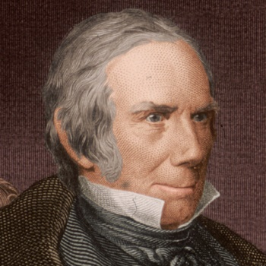 John C. Calhoun - 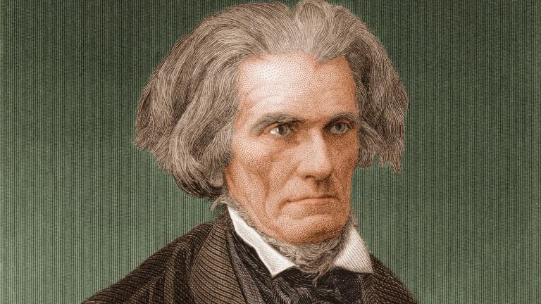
                - Together they attacked Britain in Congress constantly saying if Britain takes our sailors and impresses them, we should go to war.
              - John C. Calhoun and Henry Clay pushed harder for war in 1812. Britain said they would not stop taking our sailors and Native Americans began pushing east into states like Indiana, Illinois, and Ohio.
              - James Madison had enough of Britain he declared war in 1812. However, America was not ready for war.
            - EARLY DAYS OF THE WAR OF 1812
              - Britain and America were not in a good place for war. Britain was already fighting with Napoleon, so they had war going on with Napoleon in France, and now America declared war on them.
              - America was not ready for war because Thomas Jefferson cut the army and navy in half in 1804. America had less than 7,000 men and only 16 ships.
              - Immediately Britain sent over troops and ships and blockaded America.
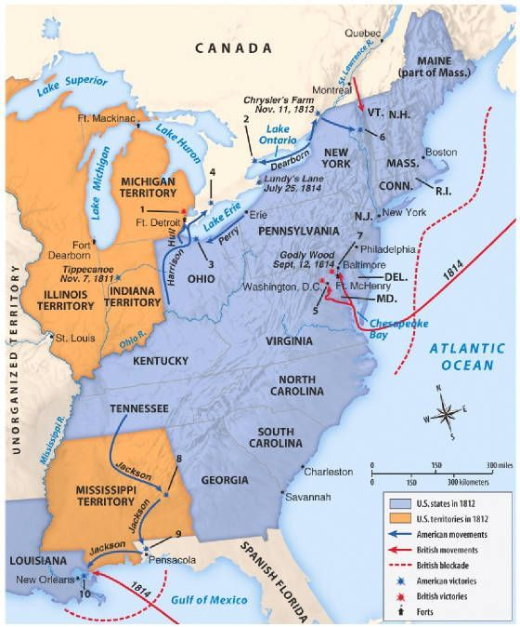
d. Most of the fighting was done on Lake Erie. The General of the Americas, Isaac Brock, took advantage of the British and won a few battles. One commander lost his battle in Lake Erie, as his ship was sinking he jumped to another ship and started fighting. His name was Oliver Hazard Perry.
              - Eventually, the Americans won control of Lake Erie, where the British had to now focus somewhere else.
              - Americans knew they needed the help of the Native Americans, however most of them joined the British in hopes they could stop Americans from pushing into their lands.
              - There was a man in the south, New Orleans who was confident he could win against the British, his name was Andrew Jackson. He was a good friend of the Native Americans. He was a General and a Indian Agent, a person who befriended the Natives. They fought along side him in the War of 1812.
            - THE FINAL BATTLES
              - Britain now goes to attack 2 cities, Baltimore and Washington D.C.
                - Britain and France made a peace treaty, so Britain sent over the remainder of their forces that were defending Britain to America. America was bombarded
                - The British march into D.C. and begin to burn many government buildings down. The most known one is the White House!
                - 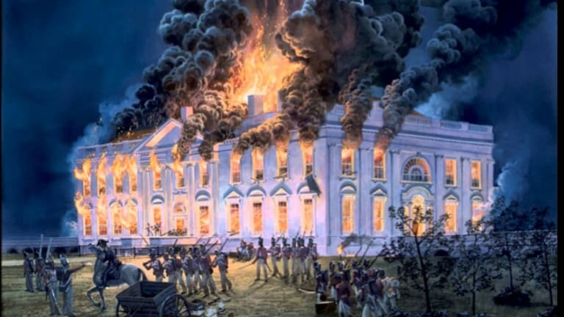
                - 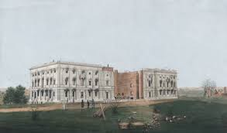
                - Dolly Madison becomes the hero of the burning of the White House. She is the wife of the President. The White House is burning to the ground, President James Madison was on the Battlefield, a few days before the burning of the White House, he asks his wife to collect any important documents in the White House and be ready to abandon the White House at any moment.
                - Dolly Madison waits for her husband to arrive back at the White House, he never does… she takes the following items out of the White House and saves them: A full portrait of George Washington, the portrait was screwed on the wall she ordered her slave Paul Jennings to break the portrait frame where it was screwed in and to be broken and rolled up the painting and took it out of the White House.
                - It was not until 1817 with the new President James Monroe was able to live in the White House again.
                - 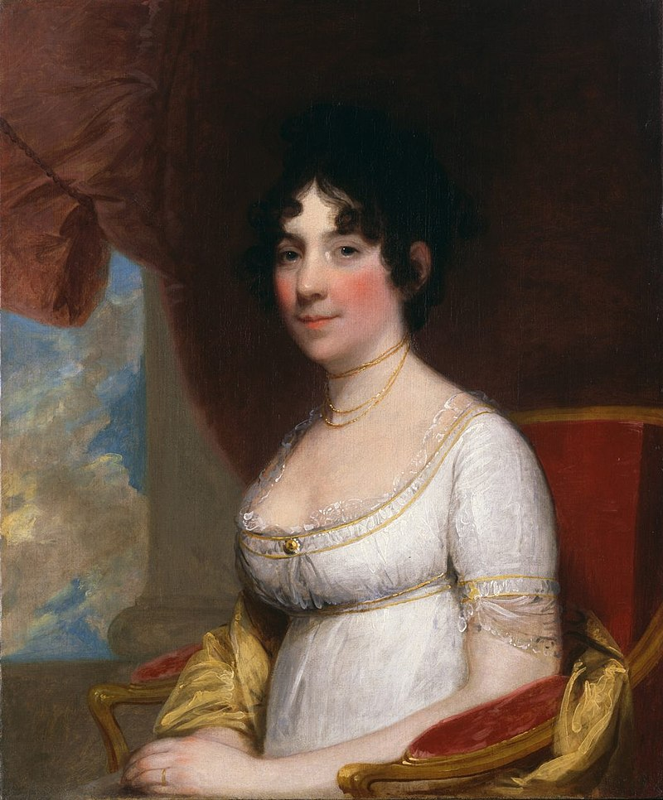
                - Dolly Madison was in charge of redesigning the White House after it had been burned.
              - Attack on Baltimore – STAR SPANGLED BANNER
                - After the burning of the White House and other buildings in D.C. the British focused on the city of Baltimore. But, only one major part, “Fort McHenry.” Fort McHenry defended the Harbor of Baltimore.
                - During the War of 1812, the British and Americans had many Prisoners of War or (POW’s). Francis Scott Key was assigned to negotiate Prisoner exchange aboard a British ship called the, HMS Tonnant. On board Francis Scott Key learns that the ships are headed to attack Fort McHenry.
                - When the negotiations are done, the British would not let him leave the ship because he knew their plans. He had to stay on the ship until the Battle was over.
                - 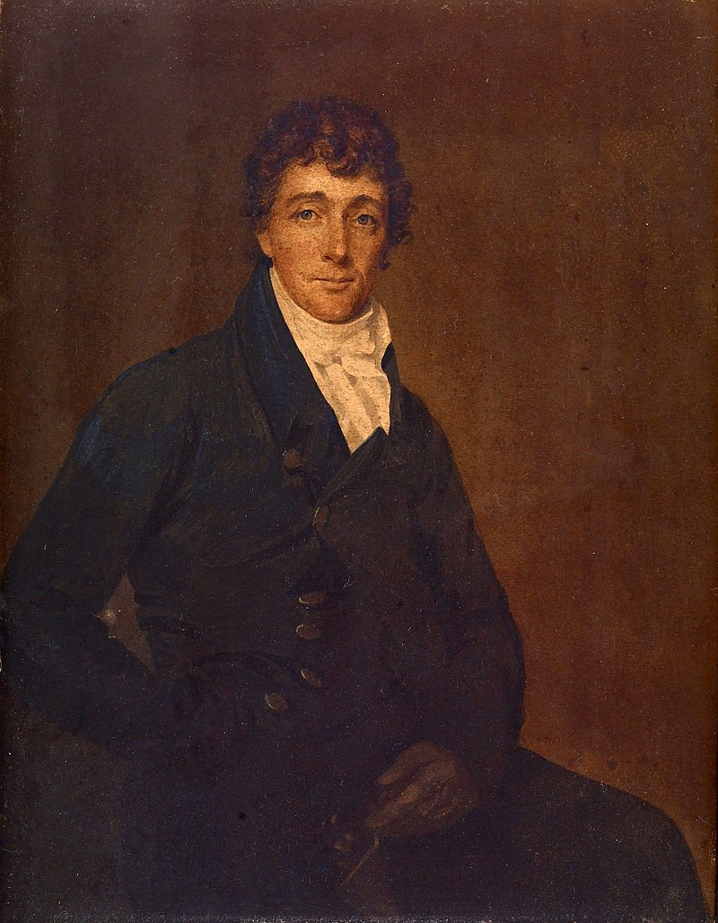
                - Francis Scott Key
                - When the Battle of Fort McHenry Begins, Francis Scott Key sees the constant bombardment of the Fort and into the evening darkness. The only way he knows the Fort has not collapsed is the large flag that is still flying over the fort.
                - Francis Scott Key on the back of an envelope begins to write a poem about what he saw. This poem was put to music in 1931 and becomes our nations “National Anthem.”
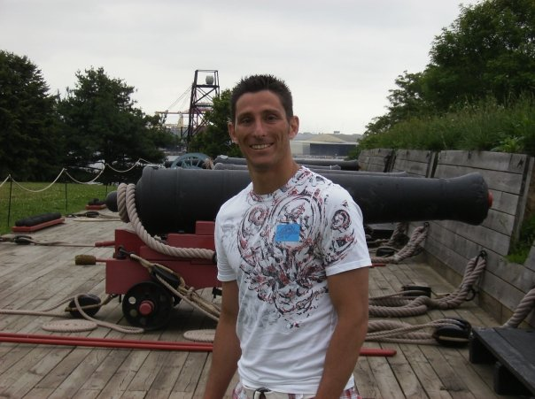
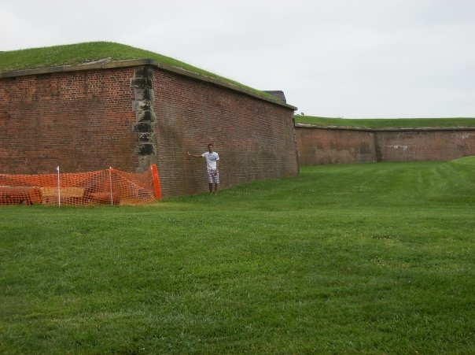
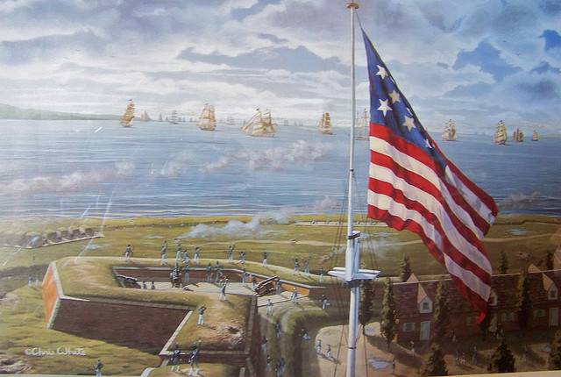
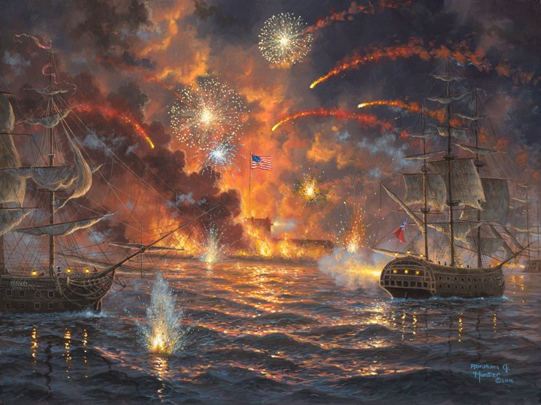
              - The War of 1812 ends with one note from James Madison asking King George to see if they can stop fighting. The British and King George Agree after over 100 years of fighting.
              - News travels slowly over the ocean, the Peace Treaty is called, “The Treaty of Ghent”
                - This Treaty makes things go back to the way they used to be before the war
              - Britain orders one final attack even though the Treaties are signed. The Attack on New Orleans.
              - General Andrew Jackson nicknamed “Old Hickory” hated the British. In the American Revolution Andrew Jackson spent time in the Prison ships. with the help of the Native Americans mainly Choctaw and hiring out Pirates in the Caribbean he attacked and battled against British forces at New Orleans and held their ground and won at night. 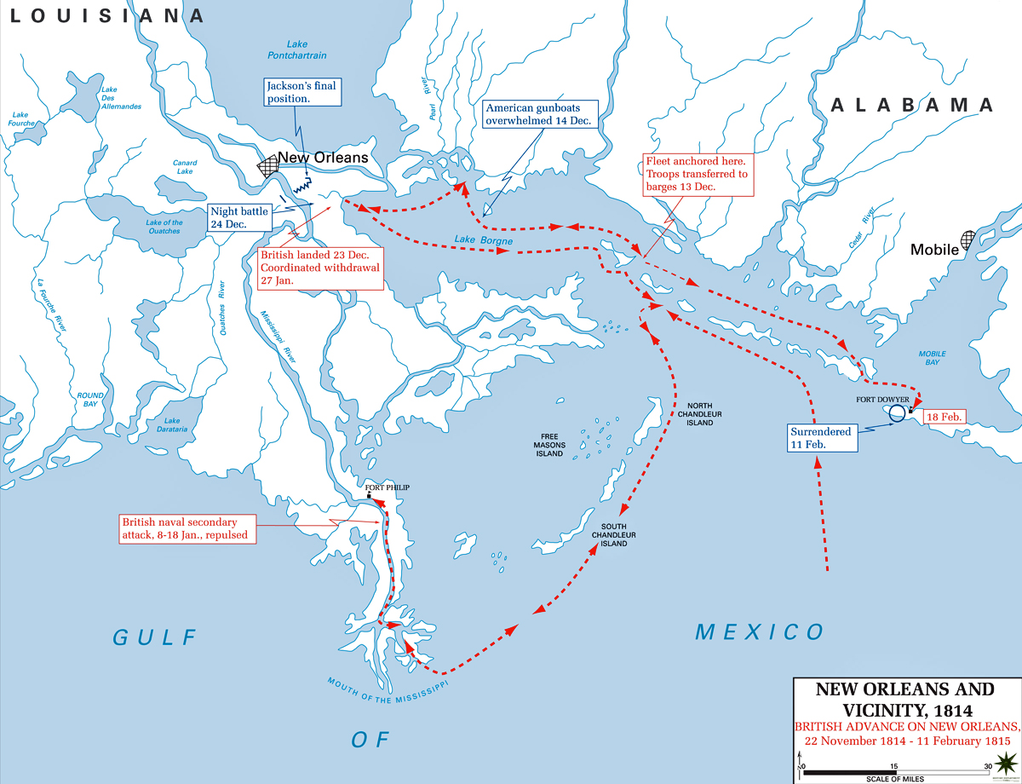
              - Jackson told his men, “and not abandon them until we drive these red-coat rascals into the river, or the swamp.”
              - Andrew Jackson after the withdrawal of the British came riding into town with the tune of, “Yankee Doodle”
              - Washington D.C. papers called him a national hero
              - 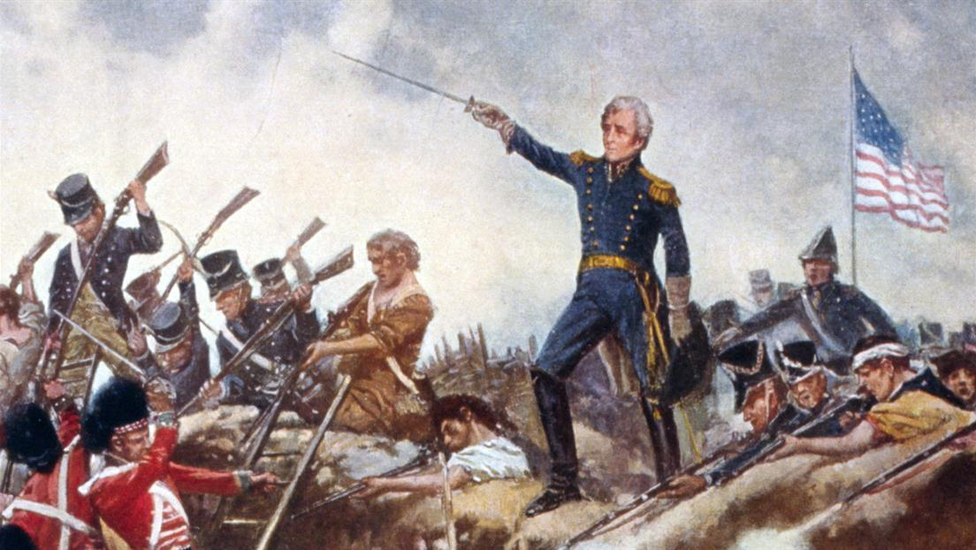
              - As the war dragged on Federalist criticized James Madison for declaring war, calling it, “MR. MADISONS WAR.” After 8 years he does not run again.

