Chapter 7 WHAT TRIBES COMPRISED THE “WESTERN” INDIANS?

I. DEFINE VOCABULARY. Write a short definition of each word as used in this chapter.

1. reservation _____________________________ 6. destitute _______________________________
2. Old Northwest __________________________ 7. shackled_______________________________

3. latitude _______________________________ 8. retaliated ______________________________
4. bombard ______________________________ 9. exile _________________________________

5. massacre ______________________________ 10. marauding____________________________
II. MAP. Identify the areas of Indian Territory 1866-1889. Print names where you can fit them. Use numbers in smaller spaces.

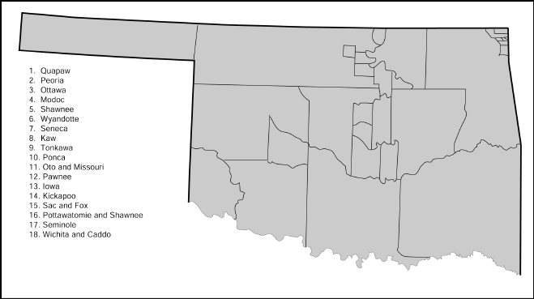

III. IDENTIFY DATES AND EVENTS. Give the year when each of the following events occurred.

______ 1. Sandusky Senecas, Mixed Senecas, and Shawnees arrived in Indian Territory to find their assigned land belonging to someone else.
______2. The Quapaws were moved and settled on the wrong land.
______3. The Quapaws had to move again.
______4. The Nez Percé signed a treaty in which the government promised them perpetual tenure of
their lands.
_____ 5. The Sac and Fox tribe was moved to Indian Territory.
______ 6. The Nez Percé were moved to Indian Territory.
***********
______ 7. The Sand Creek Massacre occurred.
______ 8. The Medicine Lodge Creek Treaty was signed.
______ 9. The Battle of the Washita occurred.
______ 10. The government declared that it would no longer deal with Indian tribes through treaties.

IV. COMPLETE THESE SENTENCES.

1. The Sandusky Senecas were remnants of the original____________________________________.
2. The Stokes Commission was appointed by President ____________________________________.
3. _____________________, Chief of the Modocs, moved his tribe back to its homeland
without government permission.
4. Chief_____________________ led the Nez Percé in a futile attempt to escape to Canada.
5. ____________________made several trips to Washington to plead for the return of his people to the Northwest.
6. At Medicine Creek, government commissioners had instructions to:
(1) ____________________________________________________________________________
(2) _____________________________________________________________________________
and (3) _____________________________________________________________________________
7. The leader of the troops at the Sand Creek Massacre was ________________________________.
8. The leader of the troops at the Battle of the Washita was __________________________.
9. The leader of the Southern Cheyennes at Sand Creek and the Washita was______________________.
10. The Wichitas, Caddoes, and Delawares, with four other tribes, were settled in the
____________________________ District.

