CHAPTER 10: A CHANGING NATION
SECTION 1: BUILDING A NATIONAL IDENTITY
- THE ERA OF GOOD FEELINGS
  - After the War of 1812, The Democratic Republicans dominated the government in the House of Representatives and the Senate.
  - In the Presidential Election of 1816, Democratic Republican James Monroe dominated the election and won the Presidency. He defeated FEDERALIST Rufus King 184 votes to 34, making the Federalist power begin to crumble.
    - Within a few years after10 this defeat the Federalist party dissolved completely.
  - President Monroe wanted to promote National Unity, people called his Presidency, “The Era of Good Feelings.” Because of this national unity promotion, no one ran against him in the Election of 1820.
- BUILDING THE NATIONAL ECONOMY
  - Americans asked the Federal Government (Congress) to increase the nations national economy in all areas around the country. A few men stepped up from different regions to push Americas Economy. They would be the leaders of it.
    - Henry Clay – SPOKE FOR THE PEOPLE OF THE WEST,
      - These people needed better roads and canals to transport goods from one region to another
    - John C. Calhoun – SPOKE FOR THE PEOPLE OF THE SOUTH,
      - These people defended the idea of national unity at first, they then put more stress on the idea of states rights. Where each state could run themselves how they please.
    - Daniel Webster – SPOKE FOR THE PEOPLE OF THE NORTH –
      - These people did not want high tariffs (import taxes), but they later liked them to support and protect northern textile industry and the factories.
  - 2ND BANK OF THE UNITED STATES
    - Americans felt that having just one Bank of the United States was not a good idea anymore, the 1st BANK OF THE UNITED STATES was made in 1791. In 1811, they voted to get rid of this Bank of the United States.
    - Without a Bank of the Untied States, money was not well handled. The Economy suffered! State banks gave out too many loans and did not get their money back.
    - Congress re-establishes the Bank of the United States, it gave out loans to individuals and controlled the amount of money the government had to spend.
  - TARRIFF OF 1816
    - During the Embargo Act, it forced Americans to create goods at home in America, boosting American economy! However, once the War of 1812 was over, businessmen in Britain started selling their goods in America at a cheaper price.
    - British business begins to rise, American business begin to fail.
    - Because of this, America creates the TARRIFF of 1816, making it where Britain must pay a tax on any of their goods coming in. This makes America rich again!
  - HENRY CLAYS “AMERICAN SYSTEM”
    - This was created by the newly founded WHIG PARTY
      - WHIG PARTY – Was created after the Federalist Party collapsed, some of the former Federalists pushed it like Daniel Webster and Henry Clay. However, the WHIG PARTY was not a direct result of Federalist party dying out. Some
    - As Tariff taxes rose, Henry Clay came up with an idea to help every region of the country, NORTH SOUTH AND WEST.
    - Henry Clay called his plan “THE AMERICAN SYSTEM” Clays system called for High Tariffs not just in the North but in all regions of the United States.
      - Tariffs Idea #1 – High Tariffs brings in money to the North for them to buy farms goods from the South
      - Tariffs Idea #2 – High Tariffs brings in money to the federal government to build roads for people West
      - Tariffs Idea #3 – High Tariffs brings in money to the North to build more factories to push textiles (clothes and thread making)
    - Clays system never really took off like everyone wanted, but it made the United States united in our economy after the War of 1812.
- TWO IMPORTANT SUPREME COURTY RUILINGS
  - The Supreme Court also promoted national economic growth and power of Congress during the Era of Good Feelings. Led by Chief Justice, “JOHN MARHSALL” a friend of the former FEDERALIST party, the court made a few new rulings.
    - 1819 – McCulloch vs. Maryland
      - The 2ND BANK OF THE UNITED STATES WAS CREATED in Philadelphia, 1 year later they opened a Branch in the state MARYLAND.
      - MARYLAND took it one step forward and said, any state that wants to open a branch, must pay a 15,000 tax to Maryland’s Bank per year. BUT THE ONLY OTHER BANK WAS IN PHILIDALPHIA! SO MARYLAND WAS TARGETING THE BANK IN PHILIDALPHIA!
      - McCulloch was the Cashier of the Philadelphia Chapter of BANK OF THE UNITED STATES. He said, “IM NOT PAYING THAT TAX.”
      - As a result, Maryland sued McCulloch and the 2nd BANK OF THE UNITED STATES.
      - 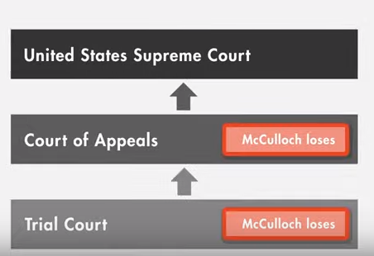1st COURT
2nd COURT
      - 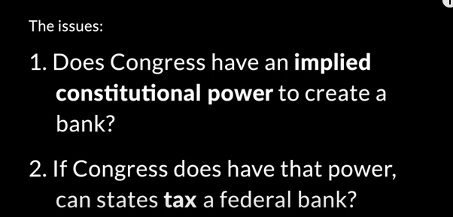
SUPREME COURT
HAD TO DECIDE
      - Supreme Court said, YES, Congress has the authority to make a National Bank
      - And NO, states cannot tax that national bank.
      - The main thing, McColloch vs. Maryland did, it made it where no state can override a NATIONAL FEDERAL LAW
    - 1814-1819 - Dartmouth College vs. Woodward
      - This court case started in 1814 and ended in 1819. It was over Dartmouth College being a private college. Well, one of the leaders, “Woodward” tried turning Dartmouth into a public university. And he succeeded for 2 years.
      - Dartmouth was one of the original colleges in America in New Hampshire, but it was created before America won its Independence, so they got approval from KING GEORGE III in Great Britain.
      - Dartmouth sued Woodward, Dartmouth said New Hampshire and Woodward did not have the right to overturn a CONTRACT made by KING GEORGE III and Dartmouth.
      - Chief Justice John Marshall agreed in favor of Dartmouth College and said that Woodward and New Hampshire did not have the right to overturn a contract made by 2 parties before New Hampshire was made as a state.
SECTION 2: DEALING WITH OTHER NATIONS
- RELATIONS WITH SPAIN
  - During the War of 1812, only America and Haiti were not under European control. Spain was the major European power in North America. However, Spain was steadily declining in power. They spent lots of money on trying to Christianize Native Americans and set up MISSIONS (Churches for Natives to learn Catholic).
  - Florida was owned by Spain as well, but not many Spanish lived there.
Runnaway Slaves
  - 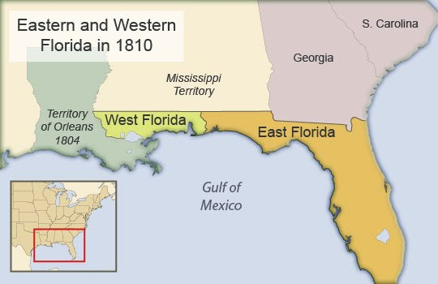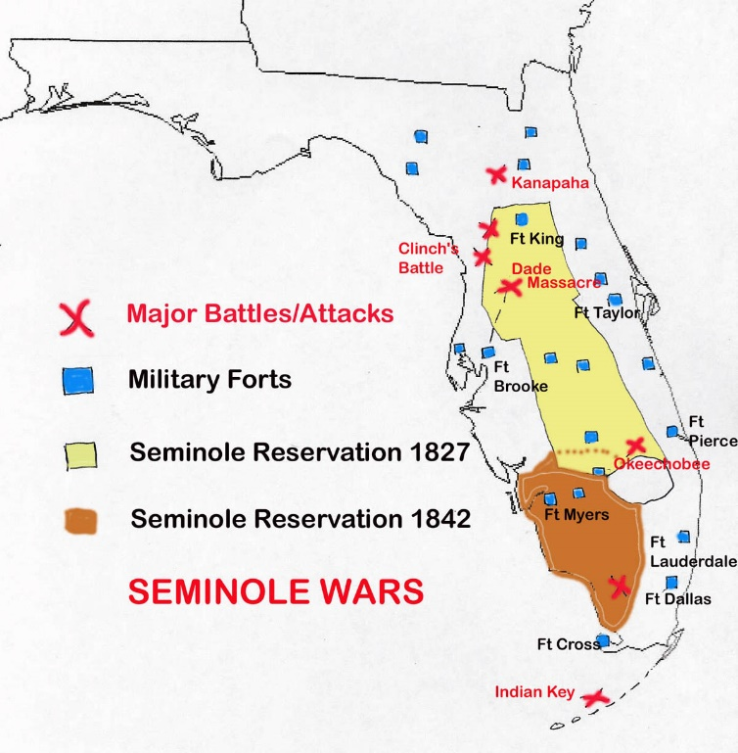
  - America purchased West Florida from Spain for 5 Million Dollars
  - The biggest issue with Spanish Florida was southern slaves were running away from their slave owners and running to Spanish Florida were slavery was banned. They would then live with the Seminole tribe!
  - Slave owners clamored to get their slaves back.
  - 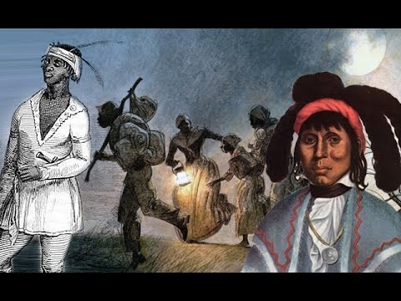
“Black” Seminole
  - Seminoles would take in the runaway slaves and treat them as their own. Today many Seminoles are African American or mixed blood between Seminole and African American. These Seminole are called, BLACK SEMINOLE
  - Slave owners asked the United States Government to do something about these FUGITIVE RUNAWAY SLAVES
  - FUGITIVE SLAVES – slaves that runaway from their slave owners running north, south, east, or west.
  - To protect their friends, the Seminoles often raided the areas of Georgia and Alabama to keep the United States from coming into Florida to get slaves back to the south.
  - America must do something about this, they hire a man who is experienced in dealing with Native Americans. They hire Andrew Jackson
  - 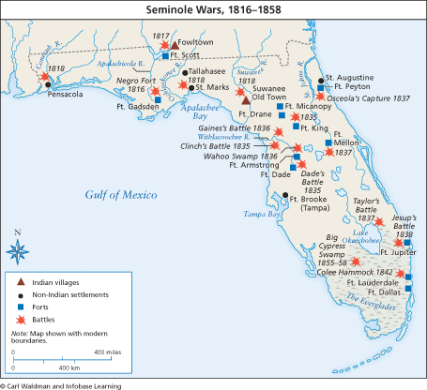
  - Andrew Jackson destroyed many Seminole Villages, went far beyond orders and took over Spanish towns and forced the Florida governor to flee. This attack showed that the United States could take Spain whenever they wanted.

- ADAMS ONIS TREATY - 1819
    - After France sold Louisiana to the United States, Spain was very upset.
    - To keep things, cool between the United States and Spain, they established a treaty or an agreement.
      - President James Monroe sent – Secretary of State John Quincy Adams (AMERICA)
      - King Ferdinand VII (7th) sent – Foreign Minister – Luis de Onis (SPAIN)
    - The Adams Onis Treaty did 3 things:
      - Spain agreed to sell Florida to the USA for 5 Million Dollars
      - It established a border between New Spain and Louisiana
      - Spain gave up its claims to Oregon Country, in return we gave them part of USA controlled Texas.
        - Spain didn’t want it anymore because of dealing with Seminole raids
        - Seminole had runaway slaves live with them from USA, USA would often come to Spanish Florida to reclaim their slaves.
        - Spain gave up Florida to the United States in the Adams Onis Treaty of 1819,
        - Americans now have Florida Territory; they want to move there. But, the problem is Native Americans are there.
        - Slave owners begin to get angry and say they want their slaves back. They told the American government they are going in, America approved. Many slaves begin to go back to their slave owners, some that were never slaves.
          - Many slave-owners lied and took slaves that were never theirs.
          - 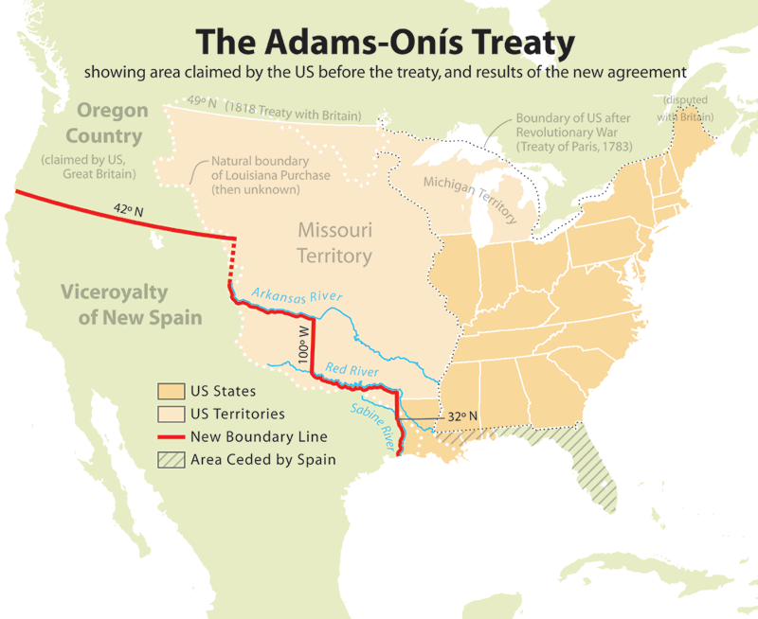
        - Because of the downfall of Spain, colonies begin to pop up and win their Independence like Mexico where they established a dictator named Antonio Lopez de Santa Ana.
        - Spain lost its foothold not only in the areas of present-day Mexico but also in South America. The United States recognized these places as independent nations.
- THE MONROE DOCTRINE
  - These new countries like Brazil, Mexico, Venezuela, Columbia, Ecuador, Panama all were very poor, not big armies and many thought Spain might regain control of them.
  - France, England, and Russia said they would help Spain if needed. America stepped in and said NO!
  - President James Monroe began trading with these new countries, like coffee, sugar. If Spain came back, the trade would diminish. Monroe crated the Monroe Doctrine.
    - MONROE DOCTRINE – Created by Secretary of State John Quincy Adams, son of John Adams. And also was written by President James Monroe . It was a statement made to Europe that America would not let them interfere with their Latin American trade. Monroe said, “If you were to attempt to interfere it would be dangerous to do so.”
  - The Monroe Doctrine continued well into the Cold War from 1945 to present day today.
SECTION 3: THE AGE OF ANDREW JACKSON
      - JOHN QUICNY ADAMS AND ANDREW JACKSON CONFLICT
        - ELECTION OF 1824
          - Andrew Jackson was the hero of America, he went in and defeated many Seminoles, he was the hero at New Orleans in the War of 1812, & he was well known for being tough known as “OLD HICKORY”. He survived a severe gunshot wound and smallpox as a kid. He was an orphan by age 14. He had firm leadership
          - Jackson would run in the Election of 1824 for President.
          - John Q. Adams was another hero of America. His father John Adams was one of the Founding Fathers of the USA. His father John Adams was the first Vice President, 2nd President, and one of the signers of the Declaration of Independence. Young John Quincy spoke many languages and was educated in France and Russia. John Quincy Adams became a very prominent lawyer just like his father and became the Secretary of State under James Monroe.
          - John Q. Adams also ran for election in 1824 for President
          - ELECTION OF 1824 ISSUE:
            - The election was so close that the House of Representatives had to vote for the President. House of Representatives chose John Quincy Adams. Andrew Jackson went ballistic. Jackson won the popular vote with the American people. Henry Clay was the leader of the House. When John Q. Adams won the election, he made Henry Clay his Secretary of State! Jackson said it was a corrupt election.
            - 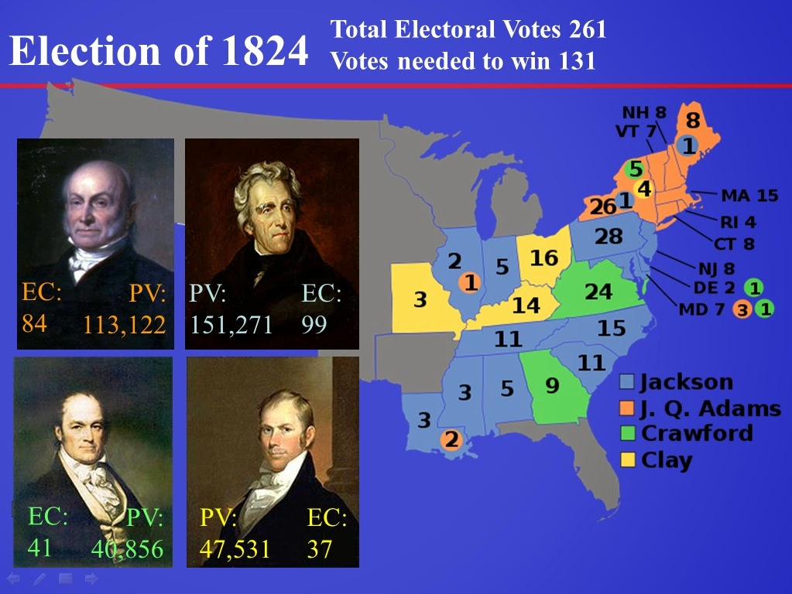
        - PRESIDENCY OF JOHN QUINCY ADAMS
          - To be honest, 6th President of the United States John Quincy Adams did very little as President. President Adams wanted to focus on INFERSTRUTCURE. Or building roads and bridges and canals for Americans to move west. President Adams pushed for Henry Clays American System with a high tariff to help make these buildings.
          - President John Q. Adams never got the trust of the people. He only served for 4 years. Many Americans thought he cheated in the election. He stays as a Congressmen for years after his Presidency and continues to be a lawyer.
      - A NEW ERA IN POLITICS
        - Americans begin pushing for a new thing in American politics called, SUFFRAGE – “THE RIGHT TO VOTE”
        - No more people who owned land could vote male. Women still could not vote.
        - Americans who supported Andrew Jackson became known as: “JACKSONIANS”
          - Most of Jacksons supporters did not trust the government. They did not trust banks,
        - Andrew Jackson believed that all people should be able to be in office, not just the RICH!
        - 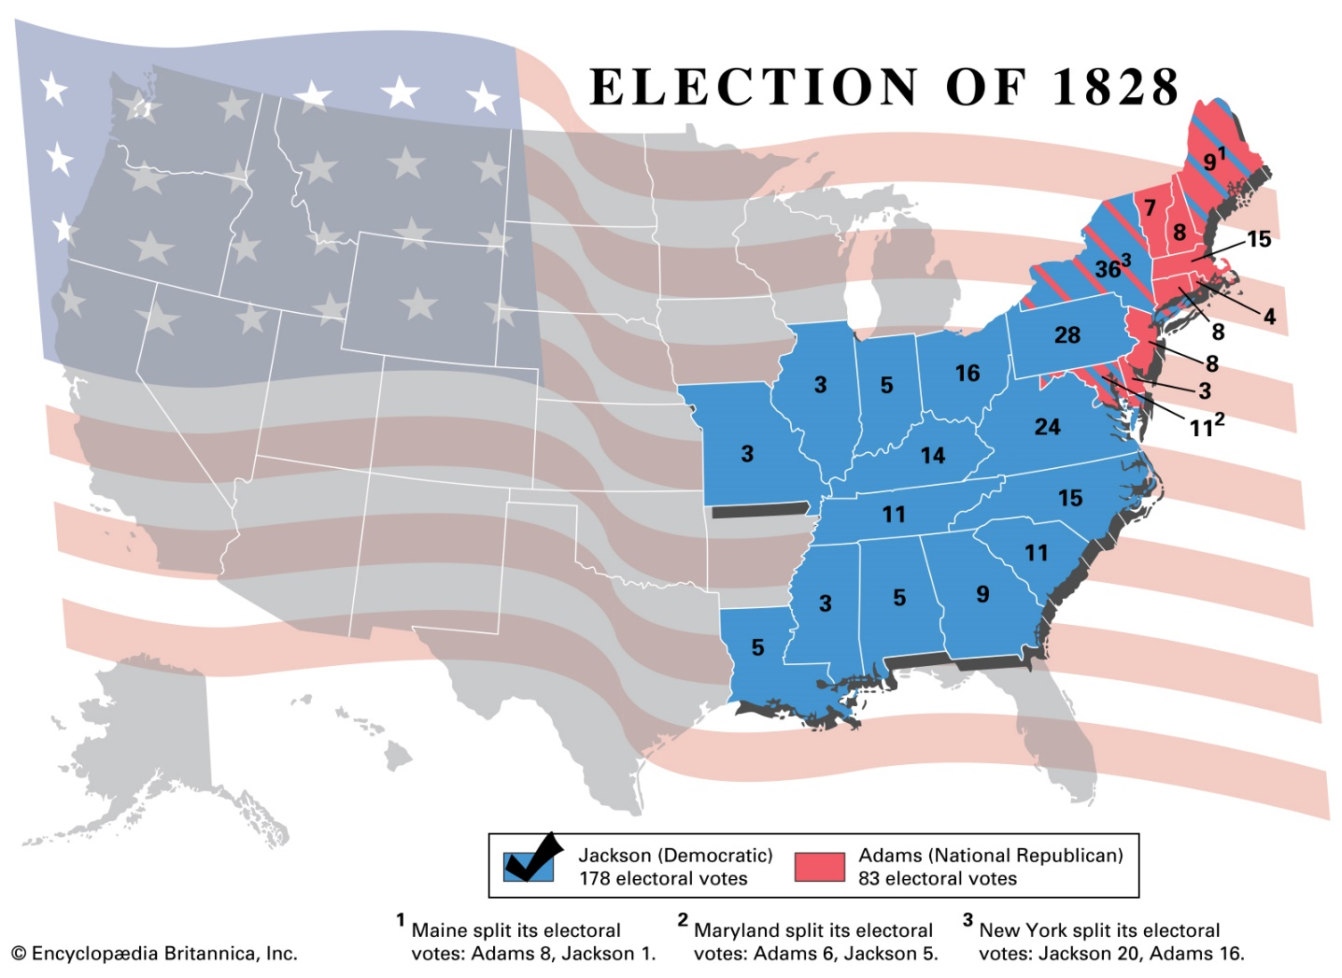
        - Andrew Jackson ran for President again in 1828 – His supporters used the word “DEMOCRAT” during the election. Most of his votes came from first time voters, who were ordinary people.
        - John Quincy Adams – He was the President & His supporters used the word “NATIONAL REPUBLICANS”. Most of his votes came from his home in New England.
      - A NEW POLITICAL PARTY EMERGES – WHIG PARTY
        - It was created by HENRY CLAY during the Election of 1834, they wanted Roads and Canals, they wanted government to look over the new BANKS.
        - WHIGS wanted high tariffs to pay for everything, THEIR SUPPORTRERS people from the Northeast because of the factories.
        - FORMER FEDARLISTS also started to become WHIGS, and BIG BUISSNESS OWNERS !

4. WINNER OF THE ELECTION OF 1828 - Andrew Jackson wins by a landslide, more people turned out for this election than any before.
        - At Jackson’s inauguration at the White House he threw a huge party. It was so crazy and large that he nearly burned the White House down. He came riding to the White House on a white horse acting like a hero.
        - 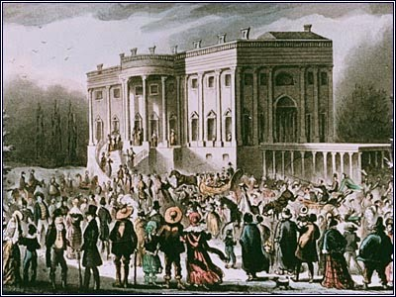
        - 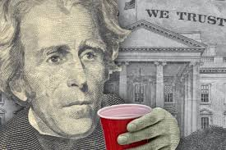
        - 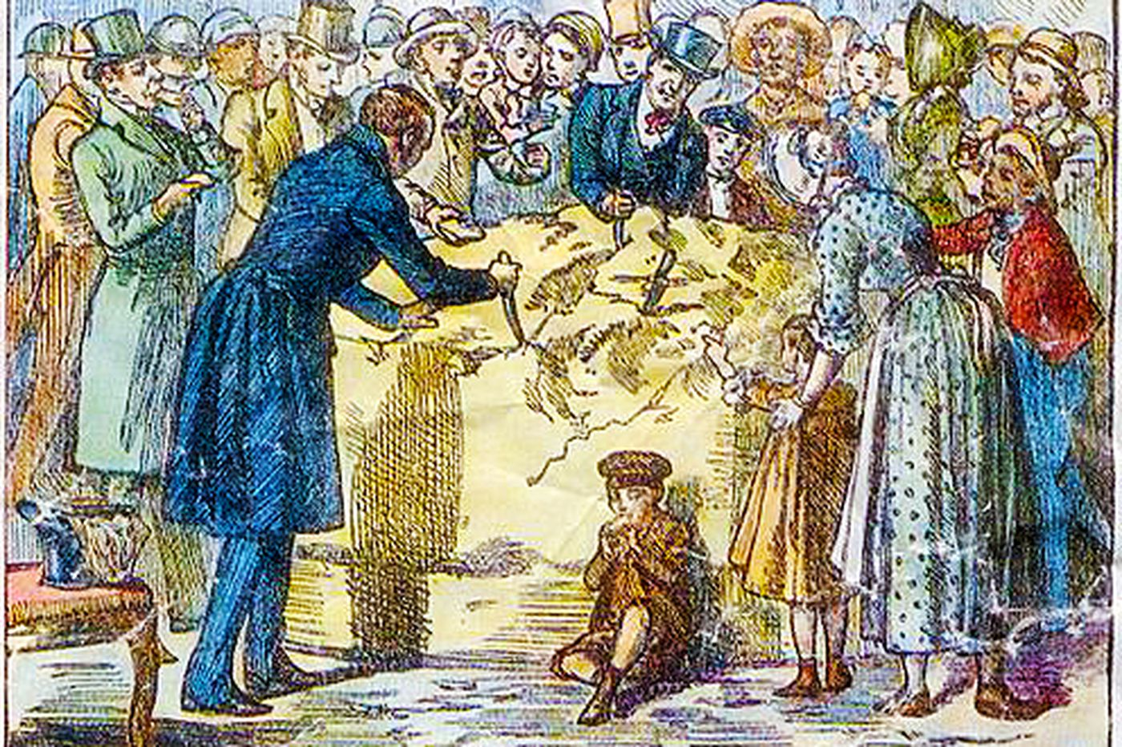
        - 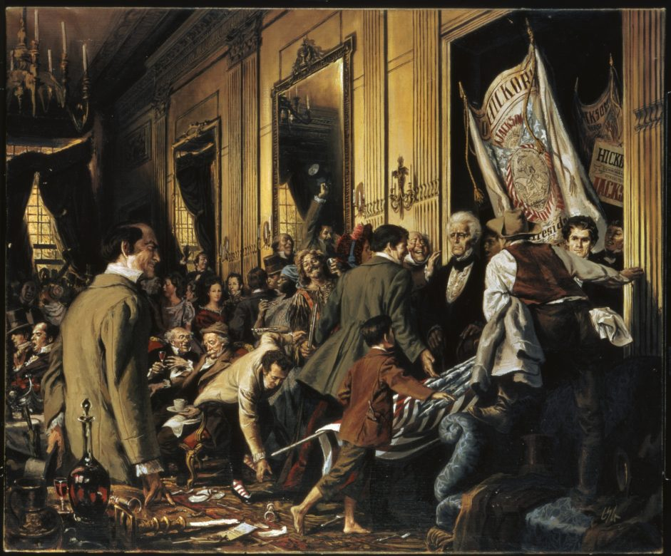
        - Jacksons supporters called Jacksons win a victory for the “common man” They called Jackson “THE PEOPLES PRESDIENT”
        - THE JACKSON SPOILS SYSTEM
            - Andrew Jackson pushed for the ordinary person to become a person who can serve in office. President Jackson began firing old government members and replacing him with his “JACKSONIANS.” He claimed that putting new people in office was a good thing.
          - One of his JACKSONIANS said, “With the victors comes the spoils” This term was called the SPOILS SYSTEM
            - THE SPOILS SYSTEM – to the practice of rewarding governmental jobs to loyal supporters of the party that wins an election.
SECTION 4: INDIAN REMOVAL
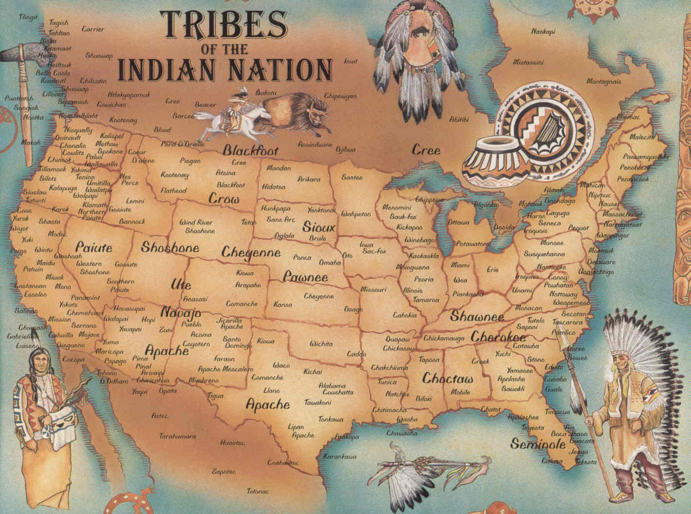
- NATIVE AMERICANS OF THE SOUTHEAST
  - In the Southeast United States, there were 5 Major Tribes that were called Civilized.
    - CIVILIZED – Where a Native American speaks English and build brick homes.
  - 5 Civilized Tribes –
    - Cherokee – Alabama & Georgia
    - Chickasaw – Mississippi
    - Choctaw – Mississippi
    - Creek – Alabama
    - Seminole – Florida
  - Facts About the 5 Civilized Tribes
    - Seminole –
      - Were once a part of the Creek Tribe, 50% of tribe today are African American called “Black Seminole.” Seminole traveled from Florida on a boat to Indian Territory most of the way. Had to live with the Creek in Indian Territory for many years. Chief was named Osceola.
    - Creek –
      - Split into 3 categories (Full Blood, Mixed Blood, & Full Blood Warriors) where they never got along and fought most of the time over which division of creek should lead. Many died of diseases and had to live with the Seminole in Indian Territory for many years. Main Chief was named Opothleyola.
    - Chickasaw –
      - The most prosperous of the tribes and wealthy, started raising cattle. They were tricked by the American Congress. America lended them money, and they did not know they had to pay it back. After they bought everything they needed. America sent them a bill, and to get rid of the debt, they agreed to move to Indian Territory.
    - Cherokee –
      - Cherokee was the largest of the tribes, most educated in white ways, had their own alphabet created by a man named “Sequoyah.” They created a newspaper called the “Cherokee Phoenix.” It was printed in English and Cherokee. They had the hardest time on removal, called the Trail of Tears. Cherokee had 3 major divisions of their people. Main tribal Chief was John Ross.
    - Choctaw –
      - 1st of the 5 tribes to be removed in 1830. Ended up getting 50% of all of Oklahoma and got paid to give it away to other tribes coming in. Andrew Jackson was their Indian Agent and friend in 1820.
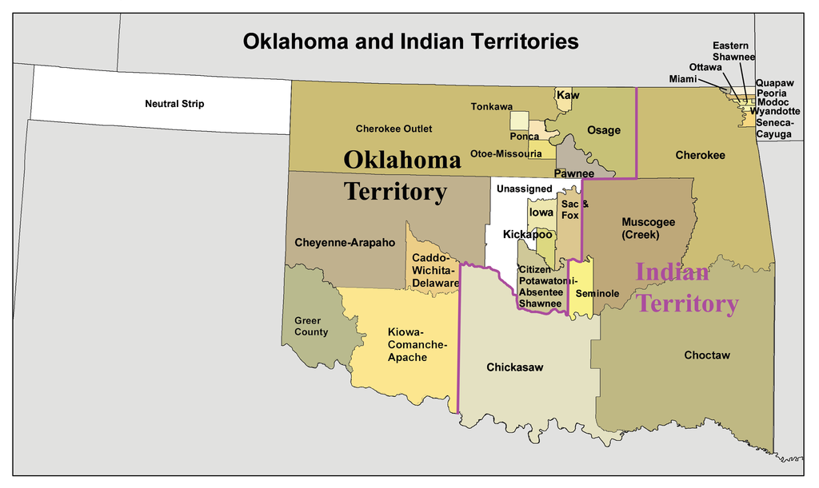
2. FACTS ABOUT ANDREW JACKSON – PRESIDENT 1829-1837 – NICKNAME “OLD HICKORY”
  - Was first a leader and General in the War of 1812, fought and won at the Battle of New Orleans
  - In 1814 he led military campaigns against the Creek Indians in Georgia and Seminole in Florida.
  - He went into Florida to fight the Seminole to retrieve runaway’s slaves that were living with the Seminole tribe in Florida.
  - He became an Indian Agent in 1818 to the Choctaw negotiating a treaty with them to move to Indian Territory
  - This is called the “Treaty of Doak’s Stand” & later “Treaty of Dancing Rabbit Creek”
  - Jackson became President from 1829-1837
  - As President he hired his supporters as his cabinet members, “SPOILS SYSTEM.”
  - Jackson forcefully removed the 5 Civilized Tribes in 1830.
  - Jackson hoped that the natives would leave voluntarily. But, they would not.
  - To get the Choctaw to move Andrew Jackson asked the State of Mississippi to put harsh laws on the Choctaw to abide by if they stayed.
  - To make things official with the Native American 5 Tribes on removing them, he said Treaties with them must be signed!
  - Created the Indian Removal Act of 1830, that removed the Native Americans.

        - 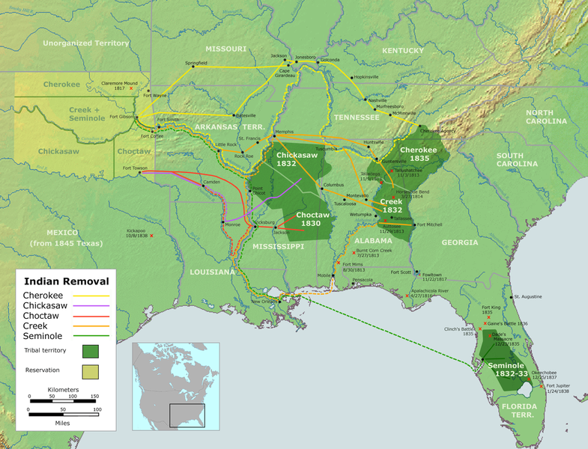
    - WORCHESTER vs. GEORGIA – (CHEROKEE vs. GEORGIA)
  - Georgia passed a law to stop Cherokee government from working in Georgia
  - Gold was then discovered in Georgia, which made whites want Cherokee to leave even more!
  - Cherokee and Georgia went to court over removal called, “Georgia vs. Worcester”
  - Sam Worcester – missionary of Cherokee who brought the case to the Supreme Court
    - Cherokee win in the Supreme Court case, they sided with the Cherokee
  - However, President Andrew Jackson ignored the Supreme Court ruling and forced Cherokee out
  - Jackson said, “Chief Justice John Marshall has made his decision, now let him enforce it”
  - As a result, Andrew Jackson tells Congress to create a law, “Indian Removal Act of 1830.”
    - Indian Removal Act 1830 - This forced Native Americans to make treaties with Congress for their removal.
    - TRAIL OF TEARS – AMERICAN NAME, TRAIL WHERE THEY CRIED – CHEROKEE NAME
      - Andrew Jackson tried to remove the Cherokee for years, but the next President Martin Van Buren was the one who got them removed from their lands. Van Buren sent Major General Winfield to remove the Cherokee
      - Removed in several parties, 1838-1839 with only the clothes they had on. 15,000 began moving
      - Very few blankets, inadequate shelter, and insufficient food. Bad water at times.
      - Disease plagued the tribe: Cholera, Measles, Pneumonia and Diphtheria.
      - No one knows the exact number of lives lost. But it was a great one. The number is over 4,000 dead.
      - Only the pregnant women got to ride in a wagon or horse.
      - Upon arrival, the Cherokee leaders were assassinated, all but two. One of them escaped and fled.
      - John Ross the only surviving leader becomes the Tribal Chief and unites the Cherokee.
SECTION 5: STATES RIGHTS & THE ECONOMY
      - THE BANK WAR 1832
        - Many people loved the 2nd Bank of the USA, but some did not. They were worried that the Bank gave out to many loans to people. Andrew Jackson did not like the 2nd Bank of the USA. Jackson felt that they Bank was “THE MONSTER” of the USA.
        - Daniel Webster and Henry Clay and Nicholas Biddle (President of the 2nd Banks of the United States) were renewing the Charter for the 2nd Bank of the USA to Continue!
          - MCULLOCH VS. MARYLAND – Said Congress can create a bank.
        - The bank was not supposed to be renewed till 1836, but Clay and Webster wanted to make it an issue in the Election of 1832
        - Jackson hated the President Nicholas Biddle of the 2nd Banks of the USA, It helped the Wealthy and not the Regular JACKSONIANS
          - Biddle gave loans to supporters of the Bank!
          - Biddle refused to give loans to Jacksons “JACKSONIANS”
        - Jackson vetoed it and said NO! IT IS UNCONSTITUTIONAL TO CONTINUE THE BANK,
          - WENT ABOVE SUPREME COURT CASE MCCULLOCH VS. MARYLAND
        - Jackson acted like he was the Supreme Court!
        - This veto showed that the President had quite a bit of authority. But, with no Bank now, the next President goes through an economic crisis.
        - People started calling Jackson, “KING JACKSON”
      - STATES RIGHTS
        - Many states wanted to operate independently rather than together as one nation. Jackson did not like this.
        - NORTH, SOUTH, & WEST all wanted different things: North = Factories, South = Farming (Cotton Tabaco), West = Farming and Livestock
        - North wanted STRONG CONGRESS to help its factories,
        - South felt each one of their states should make their own laws because they were all different.
        - West wanted canals and roads so sometimes sided with both North and South. But most of all wanted to move into new territories that wanted to become states.
      - THE NULLIFICATION CRISIS 1828
- SOUTHS ARGUMENT -
        - This crisis began at the end of John Q. Adams term and the beginning of Andrew Jackson. It was over Congress making high tariffs in 1828. This tax helped Northern, Westerners, but made Southern pay more money for making their goods.
        - Nullification – an action by a state that cancels or “NULLIFYS” a federal law to which the state objects.
        - NEW Vice President of Andrew Jackson, John C. Calhoun from South Carolina did not agree to the tariffs. He said, his state of South Carolina would not accept them.
          - SOUTHERNS DID NOT BUY THEIR GOODS FROM THE NORTH, THEY BOUGHT THEM FROM ENGLAND!
          - TARRIFF IS A TAX ON IMPORTED GOODS, SOUTH HAD TO PAY MORE! MORNEY THAN NORMAL
          - SOUTHERNS CALLED THIS THE “TARRIF OF ABOMINATIONS”
        - South Carolina and Calhoun came out and said, we can make these Tariffs Null and Void (NULLIFICATION) Calling it the “Nullification Act”
          - Vice President Calhoun said that, “If the Federal Government (Congress) can make a tax that hurts the south, could they end slavery as well?”
          - John C. Calhoun was not in favor of that, and was more about what is best for South Carolina, his home.
-NORTHS ARGUMENT -
The best argument against Nullification was by Massachusetts Senator Daniel Webster, he said that,
“We are all agents of the same supreme power, if states can strike down laws the United States would fall apart” He was basically saying that we are the UNITED STATES FIRST, THEN INDIVIDUAL STATES.
        - The new President Andrew Jackson steps in and agrees with Webster and says, “Our Federal UNION MUST BE PRESERVED. Striking down Nullification Act
        - Because of this, John C. Calhoun resigned as Vice President and was elected a Senator of South Carolina.

4. NULLIFICATION CRISIS 1832
        - In 1832 Nullification began again. Congress passed another Tariff law but was LOWERED A LITTLE. South Carolina and John C. Calhoun called for a state convention. They voted to NULLIFY the tariffs again!
        - South Carolina said if the 1828 and 1832 Tariffs applied to South Carolina they would “SUCCEED” the United States
          - SUCCEED – Leave a country
        - President Jackson, put Federal troops in South Carolina and called their bluff…They collected all the taxes from South Carolina… Jackson, threatened to invade South Carolina and hang everyone who opposed the the tariffs.
        - South Carolina ended things peacefully. Jackson had defended the Federal Government (Congress)
6. THE END OF THE JACKSON ERA
        - Andrew Jackson got tired and retired from President after two terms (8 years). He told everyone that they should elect Martin VanBuren his Vice President.
7. The Election of 1836 the newly founded Whig party decided to select 3 candidates to run for President against Van Buren.
        - VanBuren received the majority of the votes and won. However, he came to President when the US Economy was declining.
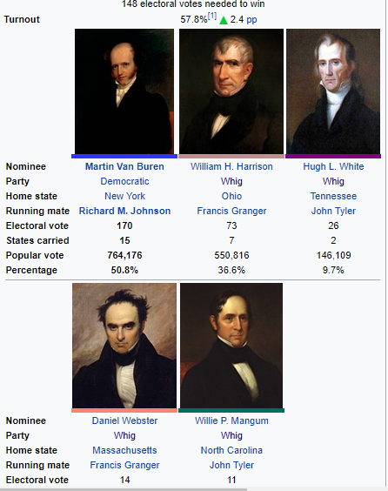
        - 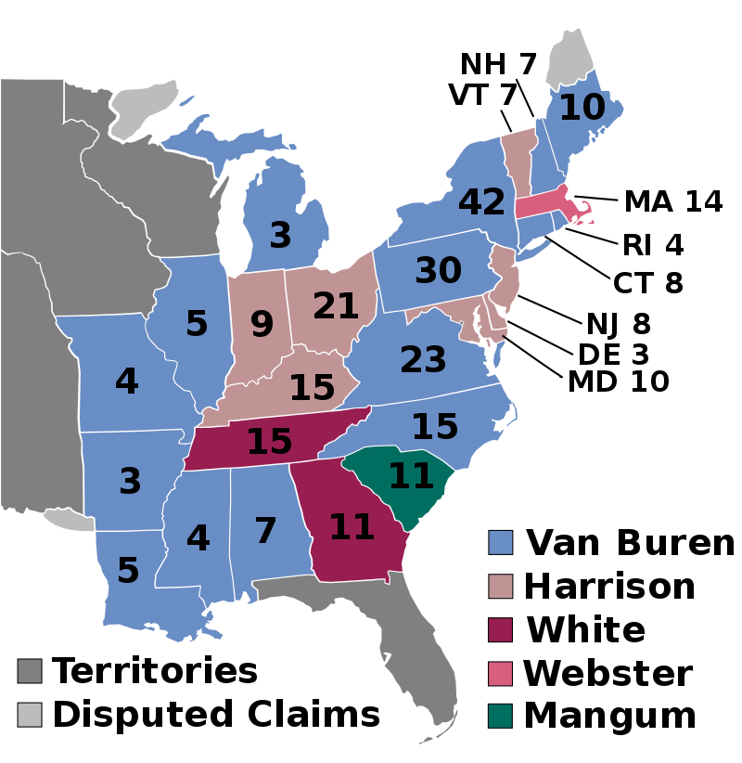
        - PANIC OF 1837
          - Britain was hurting economically so they did not buy American cotton as much. It hurt the south
          - Because the south lost money, the banks could not collect their loan debts from cotton farmers in the south.
          - This lasted for 6 years, it made President Van Buren’s term as President very bad.
        - THE ELECTION OF 1840
        - 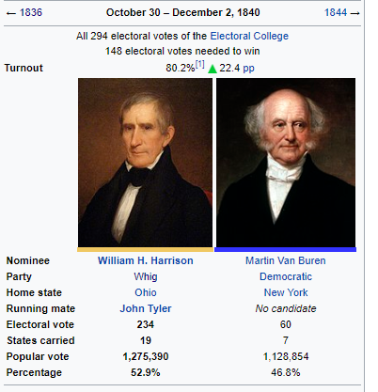
        - 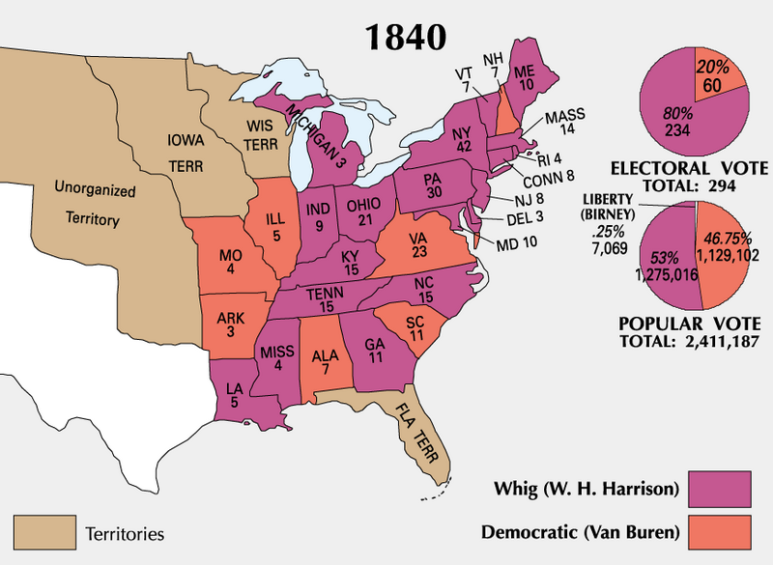
        - The Election of 1840 was the rise of the Whig Party. The Whigs chose their Candidate William Henry Harrison who was one time the Governor of Indiana & Governor of Northern Louisiana Territory.
        - President Martin Van Buren was not viewed as a good President because of the Economic Panic of 1837
        - The Whigs used parades, barbecues and had entertainment as their way of showing their candidate and party off.
        - William Henry Harrison became known as, “A Man of the People.” Whigs said he would be happy living in a log cabin! They used that slogan.
        - The Whig Party and William Henry Harrison defeat Martin Van Buren and the Democrats. The Jacksonian Era was done!

